# Homework -01: MNIST Handwritten Digit Classification

**Task and Goals:**

1. Run the basic train and find most feasible hyper parameters

> a) find feasible learning rate, activation and optimizer function, epoch size

> b) load the other test dataset (excel) to check the accuracy and save the predicted results in .csv

2. Change the optimizer and on best model you tested and do all the sub section of 1.

**Summary:**

* The shallow NN with RMSProp() optimizer has better accuracy of 98.33% than Adam() optimizer of **98% with same hyper parameters**

**Solution:**

1. **Import necessary libraries**

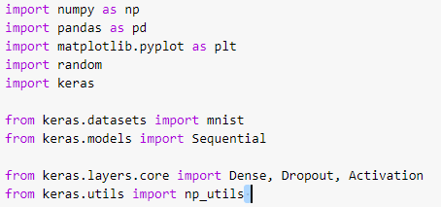

1. **Load the data set (image and csv )**

Image data loading will be used for training the model and csv data loading will be used for evaluate the saved model in broader sense





1. **Data Preprocessing**

**Data resizing, normalize the data and assign label to each sample data**

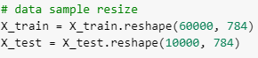

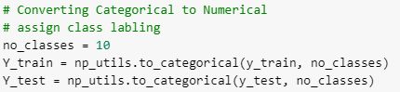

1. **Build shallow NN**

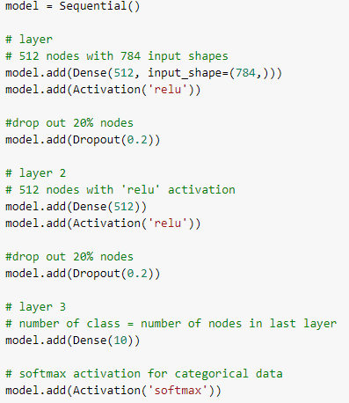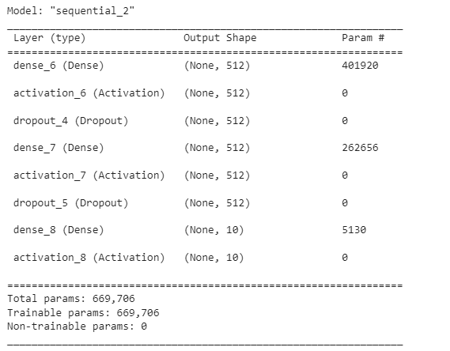

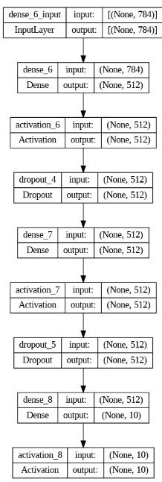

# Task 1: Find hyper parameter for base model

1. **Run the model for a learning rate = 0.00003, optimizer = ‘Adam‘, mini batch size = 12, epoch =20**

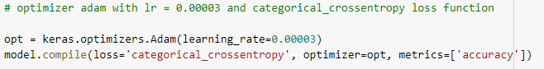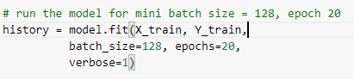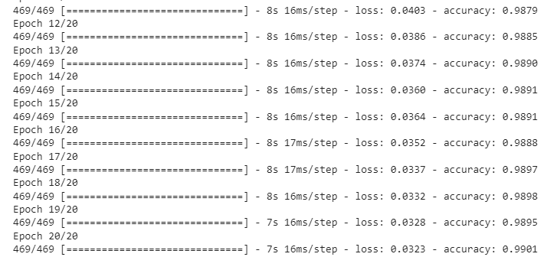

1. **Evaluate the model**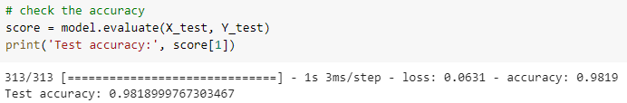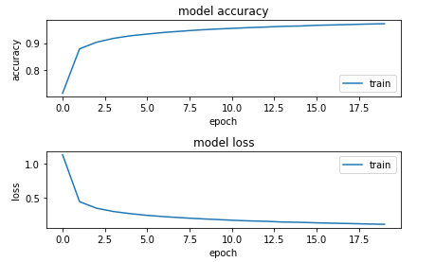
2. **Load a random similar image csv file and save the predicted result in CSV**

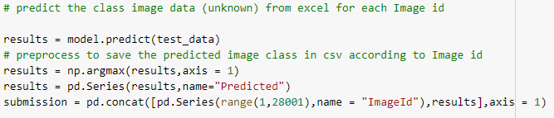



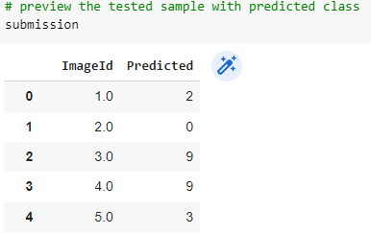

1. **Check randomly correctly classified data with prediction results**

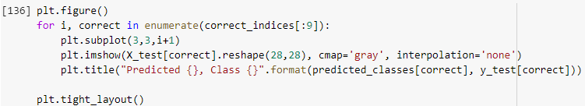

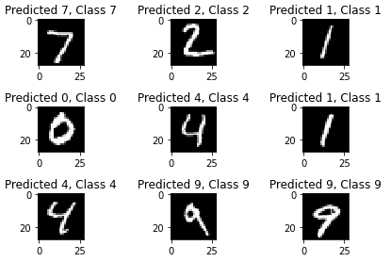

1. **Check incorrectly classified data sample**

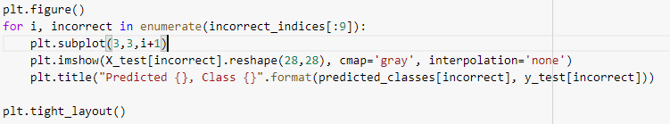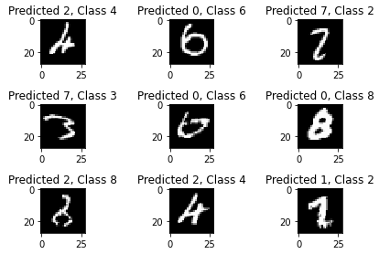

# Task 2: Check with another optimizer:

# RMSProp and continue steps from (e - i) again

**e) Run model with RMSProp optimizer**

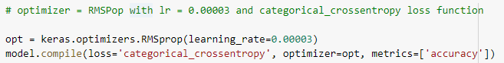 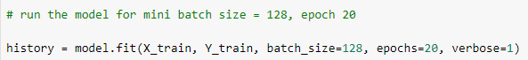

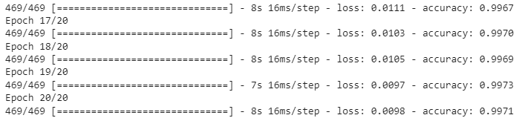

**f) Evaluate the model** 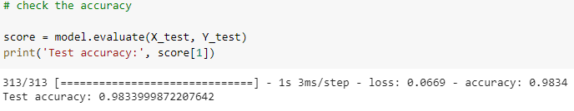 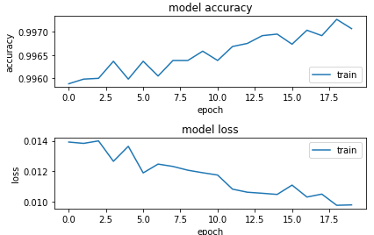

1. **Load a random similar image csv file and save the predicted result in CSV**

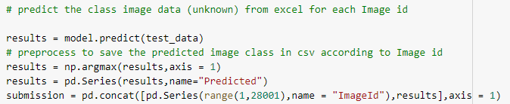 

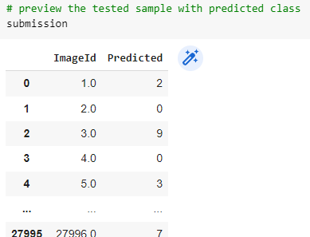

1. **Check randomly correctly classified data with prediction results**

 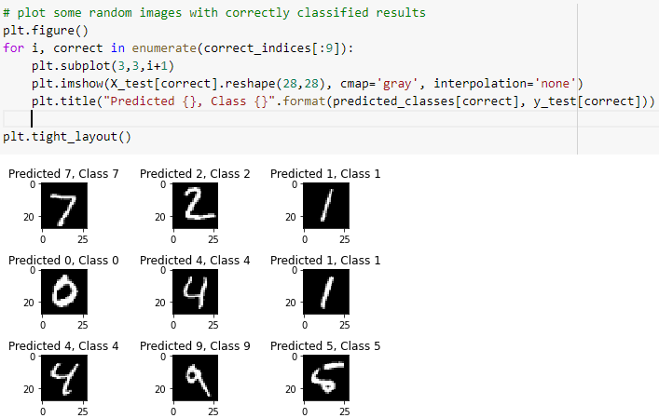

1. **Check randomly correctly classified data with prediction results**



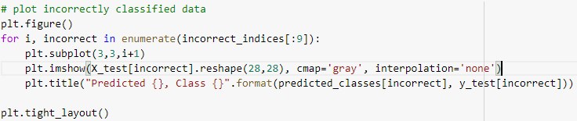 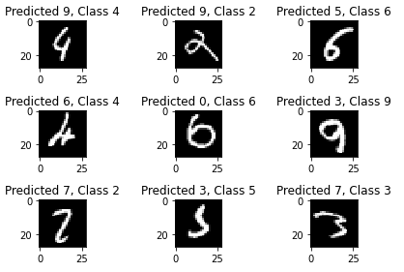

Reference:

# https://machinelearningmastery.com/how-to-develop-a-convolutional-neural-network-from-scratch-for-mnist-handwritten-digit-classification/

# https://towardsdatascience.com/image-classification-in-10-minutes-with-mnist-dataset-54c35b77a38d

# https://www.kaggle.com/code/prashant111/mnist-deep-neural-network-with-keras

# https://www.kaggle.com/code/heeraldedhia/mnist-classifier-first-deep-learning-project/notebook

# https://medium.com/fenwicks/tutorial-1-mnist-the-hello-world-of-deep-learning-abd252c47709

# https://medium.com/tebs-lab/how-to-classify-mnist-digits-with-different-neural-network-architectures-39c75a0f03e3

# https://www.kaggle.com/code/cdeotte/how-to-choose-cnn-architecture-mnist